ACADEMIA INTERNACIONAL DAVID


TECHNOLOGY
SUMMATIVE WORKSHOP # 5

NAME: __________________________DATE: ________________________________ 3^{rd Grade}: A B C
TEACHER: EDGAR PITTY
INSTRUCTIONS: READ THE WORKSHOP CAREFULLY. DO NOT USE PEN. DOUBLE ANSWERS OR CROSS OUTS ARE NOT VALID. RETURN THE ASSIGNMENT AFTER YOU FINISH OR BEFORE THE END OF THE CLASS. IF YOU KEEP THIS WORKSHOP AFTER CLASS, YOU WILL BE DEDUCTED POINTS FROM FOLLOW INSTRUCTIONS.
Name and date: 2pt |  | Follow Instructions: 1pt
Order: 1pt |  | Correct use of tools: 1pt
CONTENT: 30 pts |  | TOTAL: 35 pts

Part I: Complete the crossword with words we have seen throughout this course. 1pt each, 10 points total. _____/10.
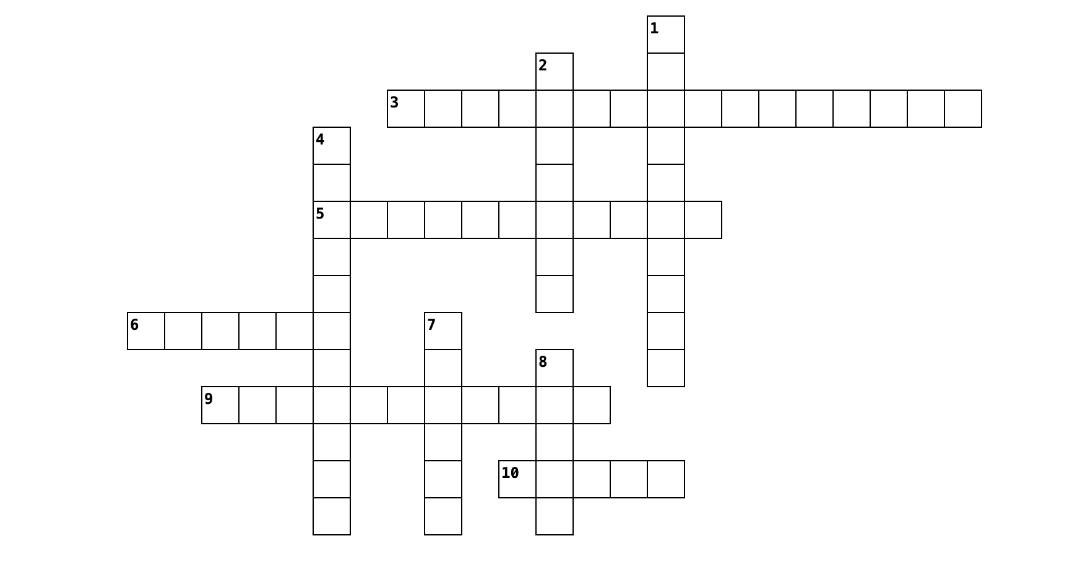

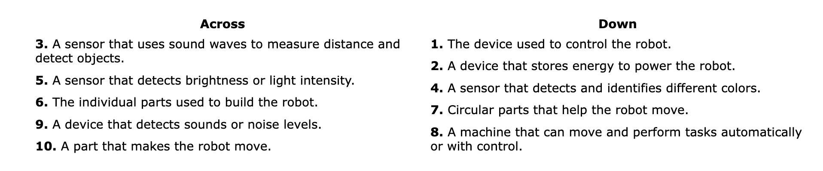
Part II: Complete the words below. 1pt each, 13 points total. _____/13.

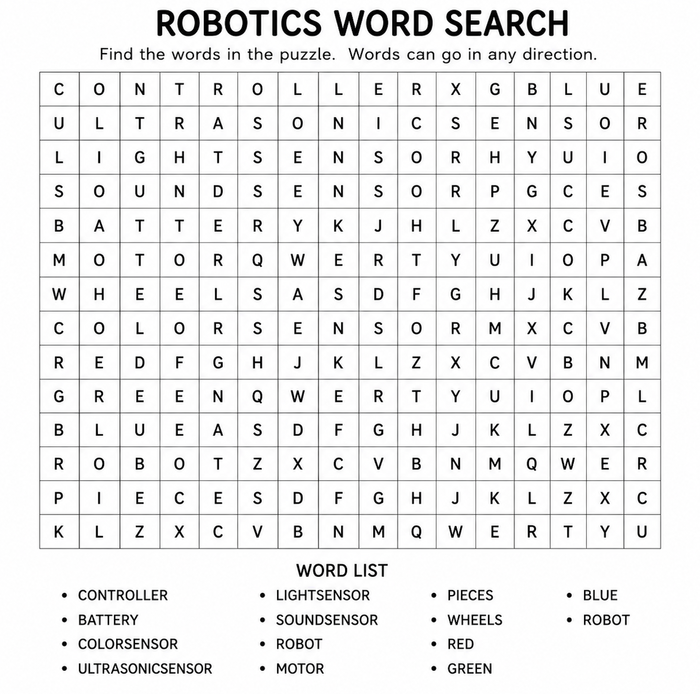

Part III: Reorder the words below. Check your spelling. 1pt each, 7 points total. _____/7.

- ROTECLONLR
Answer: _______________________________
- TERYBAT
Answer: _______________________________
- BORTO
Answer: _______________________________
- RTORMO
Answer: _______________________________
- OCLRO NESOSR
Answer: _______________________________
- SNORILUTCAS NESOSR
Answer: _______________________________
- THGIL NESOSR
Answer: _______________________________

